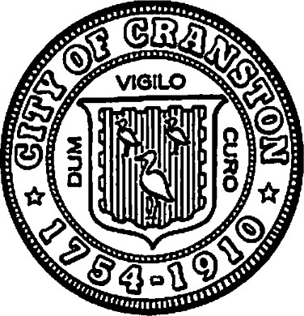

# CITY OF CRANSTON

DEPARTMENT OF COMMUNITY DEVELOPMENT

NOTICE OF FUND AVAILABILITY

# FOR PUBLIC SERVICE ORGANIZATIONS

Community Development Block Grant (CDBG) funds are available to those public service organizations that serve individuals and families residing in Cranston, and having low to moderate incomes, adjusted for family size. To qualify for CDBG funds, at least 51 % of the clientele of public service organizations must be low to moderate income people, based on the current income guidelines.

The Cranston Department of Community Development is funded by the U. S. Department of Housing and Urban Development, in accordance with the Community Development Act of 1974. Estimated CDBG grant is $1,000,000 for fiscal year July 1, 2025-June 30, 2026.

Applications can be located at www.cranstonri.gov (Community Development) or by calling or stopping at the Department of Community Development office at 401-780-6240, Pastore Youth Center, 155 Gansett Ave., Cranston, RI 02910. Applications are available January 2026.

|  |  |
| --- | --- |
| Kenneth J. Hopkins | Ernest Tommasiello |
| MAYOR | DIRECTOR |
| CITY OF CRANSTON | COMMUNITY DEVELOPMENT |